Stage 5 – How much you wanna make a bet I can throw a football over them mountains?
COURSE DESIGNER: John Royer / Outdoor Dynamics
SCORING: Comstock 28 rounds.
TARGETS: 13 cardboard targets, 2 steel targets
SCORED HITS: 2 Best hits per carboard will be scored.

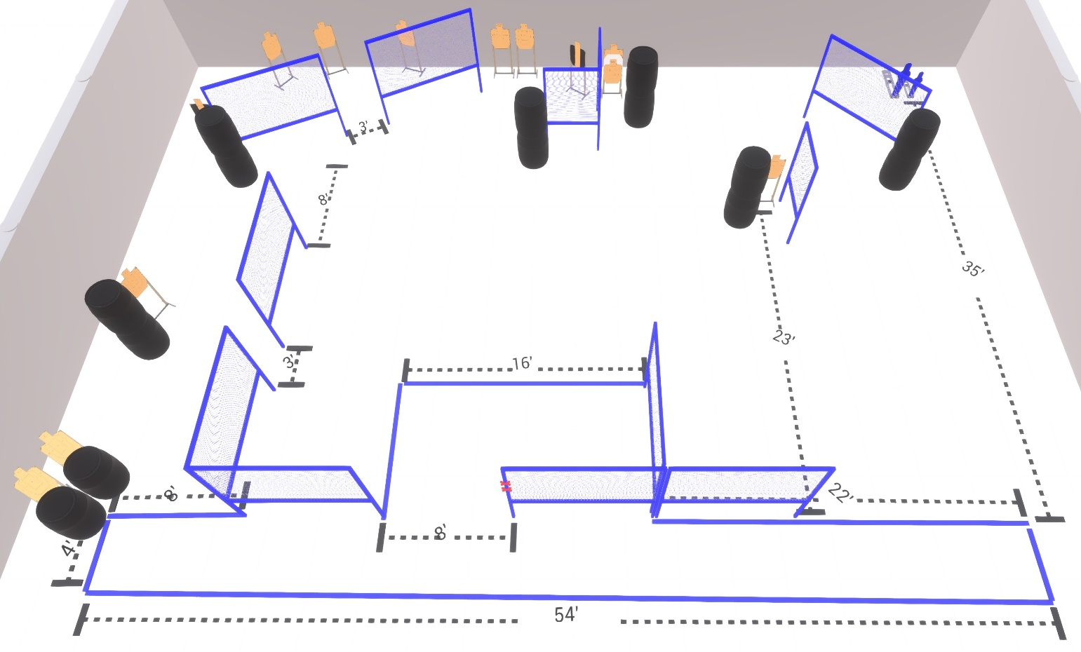

Written Stage Briefing:

Stage 5 – How much you wanna make a bet I can throw a football over them mountains? - is a 28 round, 140 point, Comstock Course. There are 13 cardboard targets and 2 steel targets

Handgun is loaded and holstered, wrists below belt, hands on marks.
PCC is loaded held in both hands, muzzle touching lower mark.

On the audible start signal, engage targets from within the shooting area.

USPSA / NROI Range Commands:
- Make Ready
- Are you ready?
- Standby
- If finished, unload and show clear
- If clear, hammer down and holster (Handgun)
If clear, hammer down and flag (PCC)
If clear, cylinder closed and holster (Revolver)
- Range is clear

Setup Notes:
17 Single Wall Stands
2 Double Wall Stands
1 Triple Wall Stands
9 Full Walls
3 Half Walls
10 Target stands / 20 target sticks
2 45 degree target stands / 4 target sticks
1 Large Popper + base
1 Small Popper + base
14+ Barrels

